**1.Create an html page named as “: Basic_Html_Tags.html” Add the following tags detail. 1. Set the title of the page as “Basic Html Tags” 2. Within the body perform the following**

a) Moving text = “Basic HTML Tags”

b) Different heading tags (h1 to h6)

c) Paragraph d) Horizontal line

e) Line Break f) Block Quote

g) Pre tag

h) Different Logical Style (<b>, <u>, <sub>, <sup>....)

i) Different Physical style (<code>, <del>, <kbd>...)

j) Listing tags (2 types with, & each type provide different “type” attribute)

|  |  |
| --- | --- |
| <!DOCTYPE html> | |
|  | | <head> |
|  | | <title>Basic_Html_Tags.html</title> |
|  | | </head> |
| <body> |
|  |
|  | <h1 align="centre">Basic HTML Tags</h1> | | |
|  | <h2 align="centre"><font colour="red" size="6">Heading Tags=>font size-18  pt, colour-RED</font></h2> | | |
|  | <h3 align="centre"><font size="7">Heading H1 - 24 pt</font></h3> | | |
|  | <h4><font size="6"><marquee>Heading H2 - 18 pt</marquee></font></h4> | | |
|  | <h3><font size="5"><b>Heading H3 - 12 pt bold</b></font></h3> | | |
|  | <h4><font size="4">Heading H4 - 12 pt</font></h4> | | |
|  | <h5><font size="3">Heading H5 - 10 pt</font></h5> | | |
|  | <h6><font size="2">Heading H6 - 7 pt</font></h6>   |  | | --- | | <p><span style="font-size: 36pt;">font size-36 pt, </span><span style="font-size: 24pt;">font size-24 pt, </span><span style="font-size: 18pt;">font size-18 pt, </span><span style="font-size: 12pt;"><b>font size-12 pt bold, </b></span><span style="font-size: 12pt;">font size-12 pt plain, </span><span style="font-size: 9pt;">font size-9 pt</span></p>  <hr>  <p align="center"><font color="green" size="5">Text Elements =>font size-12 pt, colour-GREEN</font></p> | |  |  | | |  | | --- | |  | | <blockquote cite="https://blog.hubspot.com/website/html#:~:text=HTML%2C%20short%20for%20Hypertext%20Markup%20Language%2C%20is%20the,basic%20structure%20of%20web%20pages%20and%20online%20applications.">   |  | | --- | |  | | <p>HTML, short for Hypertext Markup Language, is the core language of the World Wide Web. Originally designed as a language for semantically describing scientific documents, it has adapted to describe the basic structure of web pages and online applications. For example, HTML can be used to specify which part of the document is a title, which is a list, and which is an image. It can also be used to hyperlink a word, embed an image, italicize font, and more.</p>  </blockquote>   |  | | --- | |  | | <!--<pre>HTML, short for Hypertext Markup Language, is the core language of the World Wide Web. Originally designed as a language for semantically describing scientific documents, it has adapted to describe the basic structure of web pages and online applications. For example, HTML can be used to specify which part of the document is a title, which is a list, and which is an image. It can also be used to hyperlink a word, embed an image, italicize font, and more.</pre>-->   |  | | --- | | </body> |   </html> | |  | | |  | | |  | |  | | | |

**1(II). To create a simple html file to demonstrate the use of different tags.**

|  |  |
| --- | --- |
|  | <html> |
|  | <head> |
|  | <title>Basic Html Tags</title> |
|  | </head> |
|  | <body> |
|  | <center> <FONT COLOR="#0000FF"> Listing Tags</FONT></center><h4> Numbered List:</h4><ol><li>java</li> |
|  | <li> prel </li> |
|  | <li> C++</li> |
|  | </ol><h4> Letters List: </h4><ol type="A"> |
|  | <li> smtp </li><li>http </li><li>ftp </li> |
|  | </ol> |
|  | <h4> Lowercase Letters: </h4><ol type ="a" start="2"> |
|  | <li> php </li><li>Javascript </li><li> ajax </li> |
|  | </ol> |
|  | <h4>Roman Numbers List:</h4><ol type="I"> |
|  | <li> DTE </li><li>JCTE </li><li> SITTER </li></ol> |
|  | <h4> Lowercase Roman Number List:</h4> <ol type="i" start="4"> |
|  | <li>Computer Engg. </li><li>Mechanical Engg. </li><li>Electronics Engg. </li> |
|  |  |
|  | <h4>Here is a Nested Ordered List:</h4><ol type="I"> |
|  | <li> Module 1 </li><li>Module 2<ol type="i"> <li> Module 2.1></li><li> Module 2.2></li></ol> </li><li> Module 3 </li></ol> |
|  |  |
|  | <h4> Disc Bullet List:</h4> <ol type="Disc" > |
|  | <li>keyboard. </li><li>Mouse</li><li>Monitor </li> |
|  | </ol> |
|  | <h4>Circle Bullet List:</h4> <ol type="Circle"> |
|  | <li>CRT< /li><li>LCD </li><li>LED </li> |
|  | </ol> |
|  | <h4>Square Bullet List:</h4> <ol type="square"> |
|  | <li>Windows< /li><li>Linux </li><li>Android </li> |
|  | </ol> |
|  | <h4>A Definition List:</h4> |
|  | <dt>Coffee</dt> <dd>Black Coffee OR Milk Coffee</dd> |
|  | <dt>Milk</dt><dd> Hot White Milk OR Cold Chocolate milk</dd> |
|  | </body></html> |

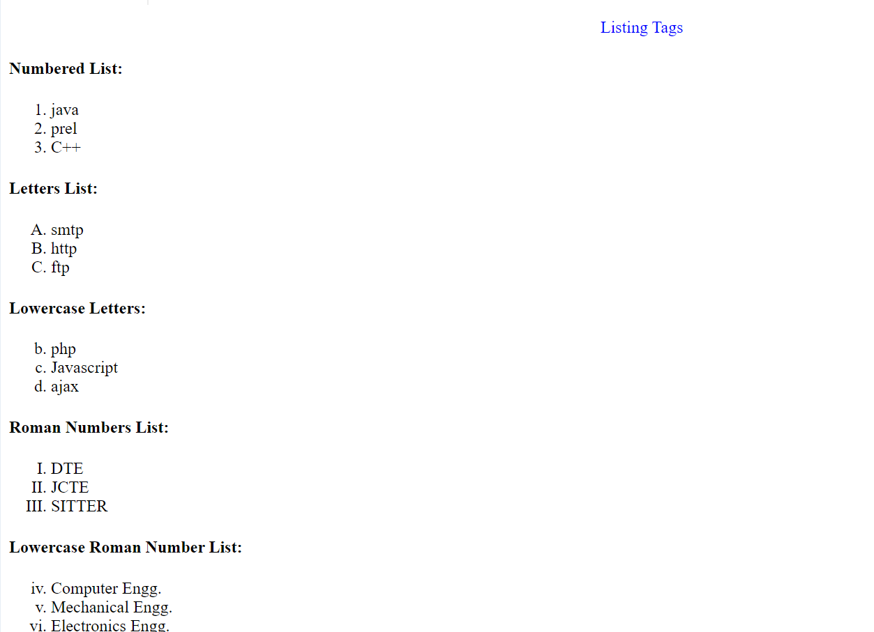

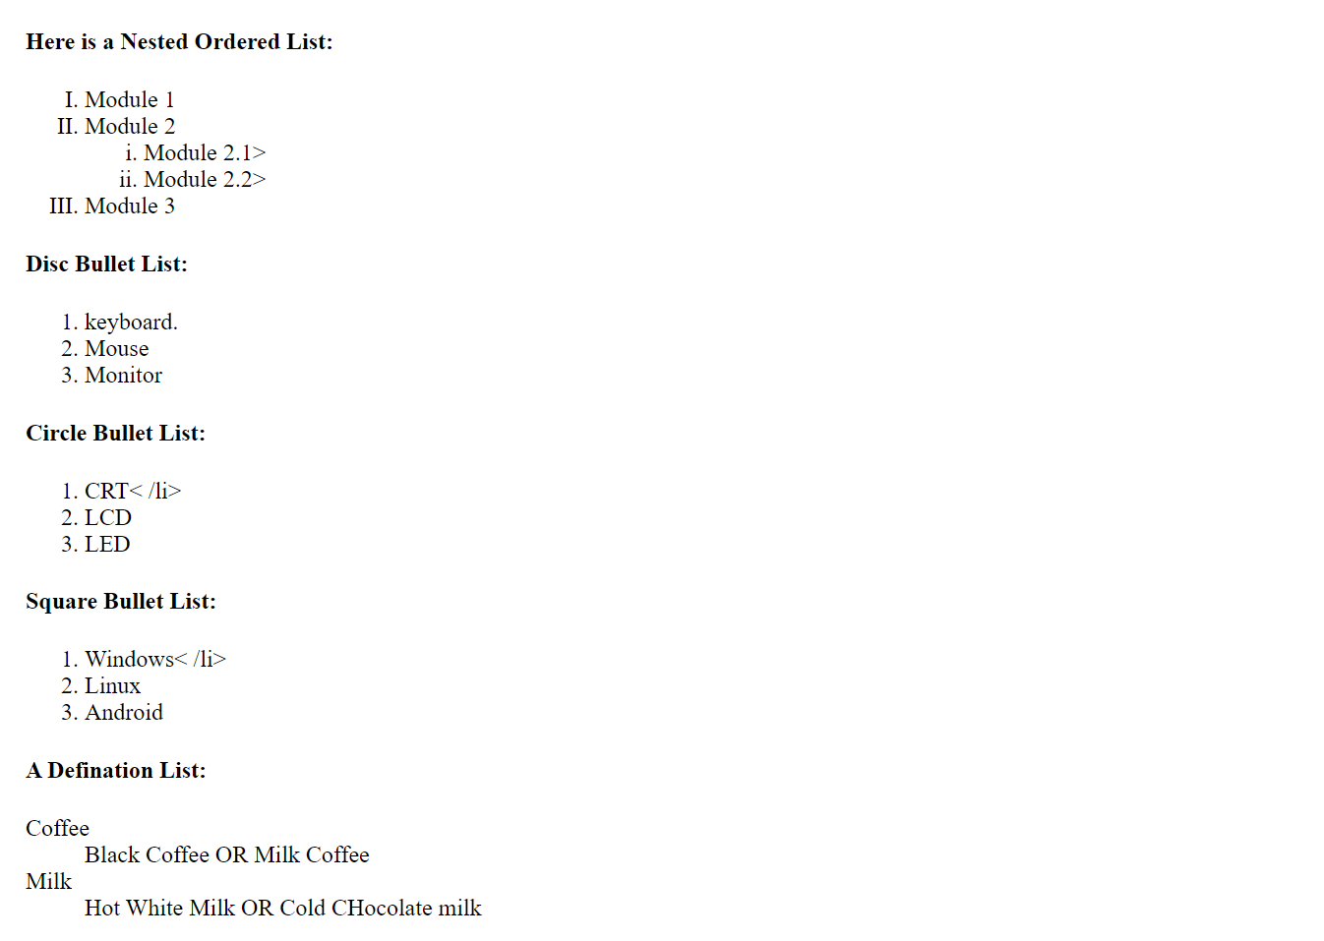

**3. Design a HTML page for the time-table as given.**

|  |  |
| --- | --- |
|  | <html> |
|  | <head> |
|  | <title><Timetable</title> |
|  | </head> |
|  | <body><h1 align ="center"><b>Government Polytechnic College |
|  | <br>DEPARTMENT OF computer Engineering <br>EFFECTIVE FROM: 01-07-2016<br></h1> |
|  | <h4 align ="center" >Semester 5 CT&nbsp&nbsp&nbsp&nbsp&nbsp&nbsp&nbsp&nbsp&nbsp&nbsp&nbsp&nbsp |
|  | &nbsp&nbsp&nbsp&nbsp&nbsp&nbsp&nbsp&nbsp&nbsp&nbsp&nbsp&nbsp&nbsp&nbsp&nbsp&nbsp&nbsp&nbsp&nbsp&nbsp&nbsp |
|  | &nbsp&nbsp&nbsp&nbsp&nbsp&nbsp&nbsp&nbsp&nbsp&nbsp&nbsp&nbsp&nbsp&nbsp&nbsp |
|  | &nbsp&nbsp&nbsp&nbsp&nbsp&nbsp&nbsp&nbsp&nbsp&nbsp&nbsp&nbsp&nbsp&nbsp&nbsp&nbsp |
|  | &nbsp&nbsp&nbsp&nbsp&nbsp&nbspR.NO:306</h4> |
|  | <table border="2" align="center" cellpadding="15"> |
|  | <tr bgcolor="pink"> |
|  | <th bgcolor="yellow"> periods </th> |
|  | <th rowspan="2" >1<BR>9:00-9:55</th> |
|  | <th rowspan="2">2<BR>9:55-10:50 </th> |
|  | <th rowspan="2">3<BR> 11:00-11:55</th> |
|  | <th rowspan="2">4<BR>11:55-1:00 </th> |
|  | <th rowspan="2"> 5<BR>2:00-2:50</th> |
|  | <th rowspan="2">6<BR>2:55-3:45 </th> |
|  | <th rowspan="2">7<BR>3:45-4:30 </th> |
|  | </tr><tr><th bgcolor="red"> days</th> |
|  | </tr> |
|  |  |
|  | <tr align="center"> |
|  | <td bgcolor="grey"> MONDAY </td> |
|  | <td > IT0302</td> |
|  | <td >IT0306 </td> |
|  | <td >IT0304 </td> |
|  | <td >IT0306 </td> |
|  | <td >IT0302 |
|  | </td ><td colspan="2" >IT0324</td> |
|  | </tr> |
|  |  |
|  | <tr align="center"> |
|  | <td bgcolor="grey"> TUESDAY </td> |
|  | <td colspan="4" bgcolor="cyan"> IT0320/IT0322</td> |
|  | <td bgcolor="rgb(255,255,0)">IT0310</td> |
|  | <td >IT0304</td> |
|  | <td >IT308</tr> |
|  |  |
|  | <tr align="center"> |
|  | <td bgcolor="grey"> WEDNESDAY </td> |
|  | <td colspan="2" bgcolor="yellow">ELECTIVE -I</td> |
|  | <td>IT0306</td><td>IT310</td> |
|  | <td>IT304</td> |
|  | <td>IT308</td> |
|  | <td>COUN</td> |
|  | </tr> |
|  |  |
|  |  |
|  | <tr align="center"> |
|  | <td bgcolor= "grey"> THURSDAY </td> |
|  | <td >IT302 </td> <td >IT0304 </td> |
|  | <td colspan="2" >PD0302 </td> |
|  | <td bgcolor="green" colspan="3"> It0320/IT0322</td> |
|  | </tr> |
|  |  |
|  | <tr align="center"> <td bgcolor= "grey">FRIDAY </td> |
|  | <td >IT0308 </td> |
|  | <td > IT0306 </td> |
|  | <td >IT0308 </td> |
|  | <td >IT0302 </td> |
|  | <td colspan="2"bgcolor="red"> ELECTIVE -I </td> |
|  | <td > </td> |
|  | </tr> |
|  | </table> |
|  | </body> |
|  | </html> |

**4. To create a simple html form to demonstrate the use of different tags.**

<html>

<head>

<title>sample Registration form</title>

</head>

<body bgcolor=lightblue>

<h1><center><font color ="red" >ENTRY FORM</h1>

<form>

<label for="fname"> Enter your Name:</label>

<input type="text" id="fname" name="fname">

<br><br><br>

<label for="fname"> Enter your Age:</label>

<input type="text" id="fname" name="fname">

<br><br><br>

<label for="fname"> Enter your Address:</label>

<textarea name="fname" rows="10" col="12"></textarea>

<br><br><br>

<label for="fname">sex: &nbsp</label>

<input type="radio" id="fname" name="Female">

<label for="fname">Female</label>

<pre> <input type="radio" id="fname" name="Male" value="Male"/>Male</pre>

<br>

<label for="fname"> Nationality:</label>

<select id="fnation" name ="fnation" >

<option value="Please Select Country ">(Please Select Country)</option>

<option value="India ">India</option>

<option value="Canada ">Canada</option>

<option value="Germany ">Germany</option>

<option value="Turkey">Turkey</option>

<option value="Russia ">Russia</option>

</select>

<br><br>

<label for="lang">Languages Known:</label>

<select id="lang" name ="lang" >

<option value="Can Select More Than One ">(Can Select More Than One)</option>

<br><br>

<pre> <input type="checkbox" id="lang" name="lang" value="C"><label for="lang"> C</label></pre>

<pre> <input type="checkbox" id="lang" name="lang" value="C++"><label for="lang"> C++</label> </pre>

<pre> <input type="checkbox" id="lang" name="lang" value="VB"><label for="lang"> VB</label></pre>

<pre> <input type="checkbox" id="lang" name="lang" value="JAVA"><label for="lang"> JAVA</label> </pre>

<pre> <input type="checkbox" id="lang" name="lang" value="ASP"><label for="lang"> ASP</label></pre>

<pre> <input type="checkbox" id="lang" name="lang" value="OTHERS"><label for="lang"> OTHERS</label> <br>

</select>

<br>

<label for="fname">Enter your Password : </label>

<pre> <input type="password" id="fname" name="fname"></pre>

<pre> <input type ="Reset" value="Reset"> <input type ="Submit" value="Submit"></pre>

<br><br><br>

</body>

</html>

**4. To create a simple html file to demonstrate the use of different tags.**

4(I)**Create an html page named as “frames.html”. Divide the page into two columns of 20%, 80% size. In 20% size call the hyperlinks for “navigationframes.html”, “floatingframes.html”, “mixedframe.html”, “noframe” and make the page to be get displayed on the other column when these links are clicked.**

<html>

<body>

<a href="3navigationframes.html" target="two">navigation frame</a><br><hr>

<a href="3floatingframe.html" target="two">floating frame</a><br><hr>

<a href="3frames.html" target="two">no frame</a><br><hr>

<a href="3mixedframe.html" target="two">mixed frame</a><br><hr>

</body>

</html>

**4(II) Create an html page named as “navigationframe.html”. Divide the page into two columns of 40%, 60% size. In 40% size call the hyperlink file created in above exercise , and make the page to be get displayed on the other column when the link is clicked.**

<html>

<frameset cols="20%,*" scrolling="no" noresize>

<frame name="one" src="C:\Users\DEEPIKA\OneDrive\Documents\frames1.html"/>

<frame name="two"/>

</frameset>

</html>

**4(III)Create an html page named as “floatingframes.html”. In this file include a paragraph to explain floating frame, and in floating frame include the any html file created in the above exercise as inline.**

<html>

<frameset cols="20%,*" scrolling="no" noresize>

<frame name="one" src="frames1.html"/>

<frameset cols="40%,*" scrolling="no" noresize>

<frame name="two" src="basic.html"></frame>

<frame name="three" ></frame>

</frameset>

</html>

<html>

<body>

<h1>About Frames</h1>

<p>Frames divide a browser window into two or more separate pieces or panes, with each pane

containing a separate web page. One of the key advantages that frames offer is that we can load and

reload single panes without having to reload the entire contents of the browser window. A collection

of frames in the browser window is known as a frameset . A frameset divides the window into rows

and columns (rather like a table). The simplest of framesets might just divide the screen into two

rows, whereas a complex frameset could use several rows and columns.

<p>There is also a special kind of frame called an iframe which is a single window that can sit

anywhere inside a page.

<p>If a user ’ s browser does not support frames, the contents of the noframes element should be

displayed to the user.A body element should be placed inside the noframes element because if a

browser does not understand the frameset element, it should ignore the frameset element and the

noframes element, then display what is inside the body element contained in the noframes

element.<p>

<iframe src="C:\Users\DEEPIKA\OneDrive\Documents\labtimetablew3.html" height="50%" width="80%">

</iframe>

</body>

</html>

**4.IVCreate an html page named as “mixedframe.html” . Divide the page into two columns of 25% & 75% size. In 25% display an image and divide the 75% into two rows. (50% & 50%). In the first 50% display the video file created in previous exercise and other 50% the time table created in previous exercise.**

<html>

<head>

<title>Video in HTML</title>

</head>

<body>

<video src="C:\Users\DEEPIKA\Downloads\panda.mp4" width="560" height="340" controls></video>

</body>

</html>

<html>

<frameset cols="25%,*">

<frame src="C:\Users\DEEPIKA\Downloads\tulip.jpg"></frame>

<frameset rows="50%,*">

<frame src="C:\Users\DEEPIKA\OneDrive\Documents\labtimetablew3.html">

<frame src="C:\Users\DEEPIKA\OneDrive\Documents\frames4.html"></frame>

</frameset>

</frameset>

</html>

**5.To display an image on the website and construct a map for all circle buttons, develop the "dialler.html" HTML page. When you click on a circle, a message with a button number, such as "you push button 1," will appear.**

<!DOCTYPE html>

<html>

<head>

<title>Keypad</title>

<style>

.keypad-container {

display: flex;

justify-content: center;

align-items: center;

height: 100vh;

}

.keypad {

width: 300px;

height: 500px;

background-color: white;

border: 1px solid black;

border-radius: 20px;

display: grid;

grid-template-columns: repeat(3, 1fr);

grid-gap: 10px;

padding: 20px;

}

.keypad button {

width: 100%;

height: 100%;

font-size: 20px;

font-weight: bold;

background-color: white;

color: black;

border-color: black;

border-radius: 50%;

cursor: pointer;

}

</style>

</head>

<body>

<div class="keypad-container">

<div class="keypad">

<button onclick="showMessage(1)">1</button>

<button onclick="showMessage(2)">2<br>ABC</button>

<button onclick="showMessage(3)">3<br>DEF</button>

<button onclick="showMessage(4)">4<br>GHI</button>

<button onclick="showMessage(5)">5<br>JKL</button>

<button onclick="showMessage(6)">6<br>MNO</button>

<button onclick="showMessage(7)">7<br>PQRS</button>

<button onclick="showMessage(8)">8<br>TUV</button>

<button onclick="showMessage(9)">9<br>WXYZ</button>

<button onclick="showMessage('*')">*</button>

<button onclick="showMessage(0)">0</button>

<button onclick="showMessage('#')">#</button>

</div>

</div>

<script>

function showMessage(buttonNumber) {

alert("You pushed button " + buttonNumber);

}

</script>

</body>

</html>

**6.**

1. **Create a external style sheet named as “external_css.css” and provide some styles for h2, hr, p & a tags.**

<!DOCTYPE HTML>

<html>

<head>

<title>Basic use of css tags.</title>

<style>

h1{

color:green;

border-style: solid;

border-color:red;

border-width: .25em;

background-color: yellow;

text-align: center;

}

#nav

{

text-align: center;

}

p.dotted

{

border-style: dotted;

border-color: purple;

background-color: pink;

}

#capital

{

border-color: blue;

border-style: dashed;

background-color:greenyellow;

}

li.first::first-letter

{

font-size: 40px;

}

li.second::first-letter

{

font-size: 40px;

}

li.third::first-letter

{

font-size: 40px;

}

</style>

</head>

<body>

<h1>

This is my stylish website.

</h1>

<div id="nav">

<h2>

<pre> <a style="text-decoration:none ; color:pink" href=# >Home BackGrounds List ID vs Class</a></pre>

</h2>

</div>

<h2>

<p class="dotted" ><font color="#9900FF">This website is about me!</font></p>

</h2>

<h3>

<p><font color="#FF0000">My Top Three Favourite Things To Do</font></p>

</h3>

<div id="capital">

<font color=#ff4500>

<ol>

<li class="first">Travel </li>

<li class="second">Eat ice cream</li>

<li class="third">Read a book</li>

</ol>

</font>

</div>

</body>

</html>

1. **Create an html file named as “4Style_sheet.html” 1. Include the external style sheet with necessary tag.**
2. **Include the internal style sheet for body tags & also use class name, so that the style can be applied for all tags.**
3. **Include a <p> tags with inline style sheet.**

<!DOCTYPE html>

<html lang="en">

<html>

<head>

<meta charset="UTF-8">

<meta http-equiv="X-UA-Compatible" content="IE=edge">

<meta name="viewport" content="width=device-width, initial-scale=1.0">

<title>Document</title>

<style>

header{

background-color: #fdd300ef;

border:5px black solid;

height:80px;

width:99.6%;

}

aside{

margin-top: 20px;

float: left;

height:450px;

width:15%;

border: 5px solid black;

background-color: #fdd300ef;

}

section{

margin-top: 20px;

background-color: rgb(176, 174, 174);

border:5px solid black;

height:450px;

width:80%;

float:right

}

nav{

margin-top: 15px;

margin-left: 25px;

background-color: #fdd300ef;

height:60px;

width:96%;

border:5px solid black;

text-align: left;

box-sizing: border-box;

}

article{

margin-top: 15px;

margin-left: 25px;

height:75%;

width:96%;

background-color:aqua;

border:5px solid black;

box-sizing: border-box;

text-align: center;

line-height: 200px;

}

footer{

margin-top: 30px;

height:70px;

width:99.6%;

border: 5px solid black;

background-color: #fdd300ef;

}

.bt{

margin-top: 10px;

margin-left:5px;

float: left;

display: inline-block;

line-height:10px;

border-radius: 10px;

}

.bn{

background-color:aqua;

border:5px solid black;

border-radius: 10px;

}

.main{

width:100%;

background-color: rgb(255, 255, 255);

margin-bottom: 20px;

min-height: 470px;

}

</style>

</head>

<body>

<header>

<p style="margin-left: 10px;">header</p>

</header>

<div class="main">

<aside >

<p style="margin-left: 10px;">menu</p>

</aside>

<section>

<nav>

<div id="bt">

<button class="bn">tool1</button>

<button class="bn">tool2</button>

<button class="bn">tool3</button>

</div>

<p style= "text-align: center;">nav bar with buttons</p>

</nav>

<article>

<p >map (through mapstruction if that matters)</p>

</article>

</section>

</div>

<footer>

<p style="margin-left: 10px;">footer</p>

</footer>

</body> </html>

**III. Create an html file named as “4Style_sheet.html” 1. Include the external style sheet with necessary tag.**

<!DOCTYPE html>

<html>

<head>

<style>

div{

text-align: center;

font-size:40px;

color:white;

}

header,footer{

background-color: rgba(0, 255, 208, 0.774);}

.content{

background-color: rgb(242, 149, 164);

width:100%;

height:690px;

}

header{

width:95%;

height:80px;

margin:0px 30px 0px 35px;

position: relative;

top:20px;

line-height:70px;

}

aside{

background-color: rgba(6, 184, 164, 0.759);

height:440px;

width:20%;

float: left;

margin:45px 0px 0px 30px;

line-height: 400px;

}

article{

background-color:rgb(238, 115, 136);

height:440px;

width:70%;

float:right;

margin:45px 40px 0px 0px;

line-height: 450px;

}

.sqbox{

position: absolute;

top:420px;

background-color: rgb(206, 197, 197);

width:20%;

height:170px;

display: inline-block;

line-height:150px;

}

.sqbox:first-child {

left: 350px;}

.sqbox:nth-child(2) {

left: 625px;}

.sqbox:last-child {

left:900px;}

footer{

height:80px;

width:95%;

margin:510px 30px 0px 35px;

line-height: 70px;

}

</style>

</head>

<body>

<div class="content">

<header><p>Header</p></header>

<aside> Aside </aside>

<article>

Article

<div class="sqbox">Image</div>

<div class="sqbox">Image</div>

<div class="sqbox">Image</div>

</article>

<footer><p>Footer</p></footer>

</div>

</body>

</html>

**9. To create an HTML page to explain input and output using a calculator with the use of various predefined functions and objects in Javascript.**

Simple Calculator

<!DOCTYPE html>

<html lang = "en">

<head>

<title> JavaScript Calculator </title>

<style>

h1 {

text-align: center;

padding: 20px;

background-color: black;

color: white;

}

#clear{

width: 125px;

border: 3px black;

border-radius: 5px;

padding: 20px;

}

#equalto{

width: 125px;

border: 3px black;

border-radius: 5px;

padding: 20px;

}

.formstyle

{

width: 400px;

height: 500px;

margin: auto;

background-color: #B8860B;

border: 3px solid skyblue;

border-radius: 5px;

padding: 20px;

}

input

{

width: 20px;

background-color: white;

color: black;

border-radius: 5px;

padding: 26px;

margin: 5px;

font-size: 15px;

}

#calc{

width: 225px;

border-radius: 3px;

padding: 20px;

margin: auto;

}

</style>

</head>

<body>

<h1> JavaScript Calculator </h1>

<div class= "formstyle">

<form name = "form1">

<input id = "calc" type ="text" name = "answer"> <br>

<input type = "button" value = "7" onclick = "form1.answer.value += '7' ">

<input type = "button" value = "8" onclick = "form1.answer.value += '8' ">

<input type = "button" value = "9" onclick = "form1.answer.value += '9' ">

<input type = "button" value = "+" onclick = "form1.answer.value += '+' ">

<br>

<input type = "button" value = "4" onclick = "form1.answer.value += '4' ">

<input type = "button" value = "5" onclick = "form1.answer.value += '5' ">

<input type = "button" value = "6" onclick = "form1.answer.value += '6' ">

<input type = "button" value = "-" onclick = "form1.answer.value += '-' ">

<br>

<input type = "button" value = "1" onclick = "form1.answer.value += '1' ">

<input type = "button" value = "2" onclick = "form1.answer.value += '2' ">

<input type = "button" value = "3" onclick = "form1.answer.value += '3' ">

<input type = "button" value = "*" onclick = "form1.answer.value += '*' ">

<br>

<input type = "button" value = "0" onclick = "form1.answer.value +='0' ">

<input type = "button" value = "%" onclick = "form1.answer.value += '%' ">

<input type = "button" value = "." onclick = "form1.answer.value += '.' ">

<input type = "button" value = "/" onclick = "form1.answer.value += '/' ">

<br>

<input type = "button" value = "=" onclick = "form1.answer.value = eval(form1.answer.value) " id= "equalto">

<input type = "button" value = "C" onclick = "form1.answer.value = ' ' " id= "clear" >

<br>

</form>

</div>

</body>

</html>

**Scientific Calculator**

<html>

<style>

*{padding:0;

margin:0;

}

body {text-align:center;

background-color:#637ACB;

}

#heading {margin-top:30px;}

#form_wrapper {width:405px;

height:450px;

margin:30px auto auto 420px;

background-color:#000;

text-align:center;

border-radius:10px;

border-right:2px groove #333;

box-shadow:4px 4px 2px #666666;}

#formone{padding-top:10px;}

#display {width:380px;

height:40px;

font-size:18px;

color:black;

margin:4px;

border:2px inset black;

border-bottom:1px inset #FFF;

border-right:1px inset #FFF;

background-color:#D5F192;}

.button {width:60px;

height:60px;

margin:1px;}

.number {font-size:16px;

font-weight:bold;}

.opps {font-size:18px;}

.three {font-weight:bold;

background-color:#FBB9A8;

}

.three:hover{background-color:#F66;}

</style>

<body>

<div id="big_wrapper">

<h1 id= "heading">SIMPLE SCIENTIFIC CALCULATOR</h1>

<div id="form_wrapper">

<form id="formone" name="calc">

<input id="display" type="text" name="display" value=" "disabled contenteditable="false">

<br>

<input class="button number" type="button" value="1" onClick="calc.display.value+=1">

<input class="button number" type="button" value="2" onClick="calc.display.value+=2">

<input class="button number" type="button" value="3"onClick="calc.display.value+=3">

<input class="button three" type="button" value="C"onClick="Resetfunction(this.form)">

<input class="button three" type="button" value= "&*xF159"onClick="backspace(this.form)">

<input class="button three" type="button" value="="onClick=”evaluation(this.form)”>

<br>

<input class="button number" type="button" value="4"onClick="calc.display.value+=4">

<input class="button number" type="button" value="5"onClick="calc.display.value+=5">

<input class="button number" type="button" value="6"onClick="calc.display.value+=">

<input class="button opps" type="button" value="-"onClick="calc.display.value+=’-‘">

<input class="button opps" type="button" value="%"onClick="calc.display.value+=’%’">

<input class="button" type="button" value="cos"onClick="cos_function()">

<br>

<input class="button number"type="button" value="7"onClick="calc.display.value+=7">

<input class="button number"type="button" value="8"onClick="calc.display.value+=8">

<input class="button number" type="button" value="9"onClick="calc.display.value+=9">

<input class="button opps" type="button" value="*"onClick="calc.display.value+=’*’">

<input class="button "type="button" value="n!"onClick=”fact_function()”>

<input class="button " type="button" value="sin"onClick="sin_function()">

<br>

<input class="button opps" type="button" value="."onClick="calc.display.value+=’.’">

<input class="button number" type="button" value="0"onClick="calc.display.value+=0">

<input class="button opps" type="button" value=","onClick="calc.display.value+=’,’">

<input class="button opps" type="button" value="+"onClick="calc.display.value+=’+’">

<input class="button opps" type ="button" value="/"onClick="calc.display.value+=’/’”">

<input class="button" type="button" value="tan"onClick="tan_function()">

<br>

<input class="button" type="button" value="E"onClick="calc.display.value+=2.718">

<input class="button" type="button" value="pi"onClick="calc.display.value+=3.141">

<input class="button" type="button" value="x^y"onClick="power_function()">

<input class="button" type="button" value="("onClick="openpara(this.value)">

<input class="button" type="button" value=")"onClick="closepara(this.value)">

<input class="button" type="button" value="log"onClick="log_function">

<br>

<input class="button" type="button" value="sqrt"onClick="sqrt_function()">

<input class="button" type="button" value="LN2"onClick="calc.display.value+=0.693">

<input class="button" type="button" value="LN10" onClick="calc.display.value+=2.302">

<input class="button" type="button" value="log2E"onClick="calc.display.value+=1.442">

<input class="button" type="button" value="log10E"onClick="calc.display.value+=0.434">

<input class="button" type="button" value="EXP"onClick="exp_function">

</form>

</div>

</div>

</body>

<script>

flag = 0;

function openpara(val)

{

calc.display.value+=val;

flag+=1;

}

function closepara(valval)

{

calc.display.value+=valval;

flag-=1;

}

function backspace(calc)

{

var size = calc.display.value.length;

calc.display.value=calc.display.value.substring(0,size-1);

}

function Resetfunction(calc)

{

calc.display.value=" ";

flag=0;

}

function cos_function()

{

flag+=1;

calc.display.value+='Math.cos()';

}

function sin_function()

{

flag+=1;

calc.display.value+='Math.sin()';

}

function tan_function()

{

flag+=1;

calc.display.value+='Math.tan()';

}

function log_function()

{

flag+=1;

calc.display.value+='Math.log()';

}

function sqrt_function()

{

flag+=1;

calc.display.value+='Math.sqrt()';

}

function exp_function()

{

flag+=1;

calc.display.value+='Math.exp()';

}

function fact(x)

{

factvar=1;

for (i=1;i<=x;i++)

{

factvar=factvar*i;

}

return factvar;

}

function fact_function(x)

{

flag+=1;

calc.display.value+='fact()';

}

function power_function(x)

{

flag+=1;

calc.display.value+='Math.pow(x,y)';

}

function evaluation(calc)

{

n = calc.display.value;

var size = calc.display.value.length;

var lastchar = calc.display.value.charAt(size)

if(isNaN(lastchar) && (lastchar!=")") && lastchar!="!" ) {calc.display.value="syntax error";}

else if(flag!=0){calc.display.value="error:paranthesis";}

else {

result=eval(n);

calc.display.value=result;}

}

</script>

</html>

**10. To create an html page to explain the use of various predefined functions in window object in java script.**

**Window Object methods alert() , prompt() , confirm(), open(), close() , print()**

<!DOCTYPE html>

<html>

<head>

<title>Window Object Methods </title>

<script>

function showAlert() {

alert("Hello! This is an alert box.");

}

function showPrompt() {

var result = prompt("Please enter your name:");

if (result) {

alert("Hello, " + result + "!");

} else {

alert("You did not enter any name.");

}

}

function showConfirm() {

var result = confirm("Are you sure you want to proceed?");

if (result) {

alert("You clicked OK.");

} else {

alert("You clicked Cancel.");

}

}

function openWindow() {

window.open("https://www.bing.com/?pc=U316&form=CHROMN", "_blank");

}

function closeWindow() {

window.close();

}

function printPage() {

window.print();

}

</script>

</head>

<body>

<h1>Window Object Methods </h1>

<button onclick="showAlert()">Click me to show an alert</button><br><br>

<button onclick="showPrompt()">Click me to show a prompt</button><br><br>

<button onclick="showConfirm()">Click me to show a confirm</button><br><br>

<button onclick="openWindow()">Click me to open a new window</button><br><br>

<button onclick="closeWindow()">Click me to close this window</button><br><br>

<button onclick="printPage()">Click me to print this page</button><br><br>

</body>

</html>

**11. To create an html page to change the background color for every click of a button using**

**javascript.**

**Create a html page named as changebackground_color.html and Define a method named as random_color() which is to be called when you click on the body. This method should generate random number, which is used to set the background color.**

<!DOCTYPE html>

<html>

<head>

<title>Change Background Color Example</title>

<style>

body {

display: flex;

justify-content: centre;

}

.box {

width: 400px;

height: 200px;

background-color: whitesmoke ;

}

</style>

<script>

function random_color() {

var red = Math.floor(Math.random() * 256);

var green = Math.floor(Math.random() * 256);

var blue = Math.floor(Math.random() * 256);

document.getElementById("box").style.backgroundColor = "rgb(" + red + "," + green + "," + blue + ")";

}

</script>

</head>

<body onclick="random_color()">

<div class="box" id="box" >

<p><h1>Click me to change my color!</h1></p>

</div>

</body>

</html>

**12.To create an html page with 2 combo box populated with month & year, to display the calendar**

**for the selected month & year from combo box using javascript.**

<html>

<head>

<script language="javascript" type="text/javascript">

var i=0,j,cnt=0,c;

var days=["sun","mon","tue","wed","thu","fri","sat"];

var yr,k,mon;

var last=[31,28,31,30,31,30,31,31,30,31,30,31];

var mn=

["January","February","March","April","May","June","July","August","September","October","November","December"];

function my()

{

yr=document.form1.qual.value;

k=(document.form1.qual1.value);

if(yr%4==0)

{

last[1]=29;

}

var k1=k-1

document.write("<table width='50%' height='60%' border='9' bgcolor='cyan'>");

document.write("<tr><td colspan='7'><center>"+ mn[k1]+" "+yr+"</center></td></tr>");

document.write("<tr>");

for(i=0;i<=6;i++)

{document.write("<td align='center' > <b>"+days[i]+"</b></td>");}

document.write("</tr>");

var date2=new Date(yr,k1,1);

var daz=date2.getDay();

cnt=0;

for(i=0;i<=daz-1;i++)

{

document.write("<td></td>");

cnt=cnt+1;

}

for(j=1;j<=last[k1];j++)

{

c=cnt%7;

if(c==0)

{

document.write("</tr><tr><td align='center' >"+j+"</td>");

cnt++;

}

else

{

document.write("<td align='center' >"+j+"</td>");

cnt++;

}

}

document.write("</tr></table>");

}

</script>

</head>

<body bgcolor="green">

<h1>Calender</h1>

<h2>Select Year</h1>

<form name="form1">

<select name="qual">

<option>2016</option>

<option>2017</option>

<option>2018</option>

<option>2019</option>

<option>2020</option>

<option>2021</option>

<option>2022</option>

<option>2023</option>

</select>

<h2>Select Month</h1>

<select name="qual1">

<option value=1>JAN </option>

<option>2</option>

<option>3</option>

<option>4</option>

<option>5</option>

<option>6</option>

<option>7</option>

<option>8</option>

<option>9</option>

<option>10</option>

<option>11</option>

<option value=12>DEC</option>

</select>

<input type="button" value="ok" onclick=my()></input></form>

</body>

</html>

**13.**

1. **a) Write a JavaScript program to display the current day and time in the following format. *Sample Output :***

**Today is : Friday. Current time is : 4 PM : 50 : 22**

<!DOCTYPE html>

<html>

<head>

<meta charset="utf-8">

<title>JavaScript current day and time</title>

</head>

<body></body>

</html>

var today = new Date();

var day = today.getDay();

var daylist = ["Sunday","Monday","Tuesday","Wednesday ","Thursday","Friday","Saturday"];

console.log("Today is : " + daylist[day] + ".");

var hour = today.getHours();

var minute = today.getMinutes();

var second = today.getSeconds();

var prepand = (hour >= 12)? " PM ":" AM ";

hour = (hour >= 12)? hour - 12: hour;

if (hour===0 && prepand===' PM ') {

if (minute===0 && second===0){

hour=12;

prepand=' Noon';

}

else {

hour=12;

prepand=' PM';

}

}

if (hour===0 && prepand===' AM ') {

if (minute===0 && second===0) {

hour=12;

prepand=' Midnight';

}

else {

hour=12;

prepand=' AM';

}

}

console.log("Current Time : "+hour + prepand + " : " + minute + " : " + second);

1. **b) Write a JavaScript program to get the current date. *Expected Output* : mm-dd-yyyy,**

**mm/dd/yyyy or dd-mm-yyyy,**

**dd/mm/yyyy**

<!DOCTYPE html>

<html>

<head>

<meta charset="utf-8">

<title>Write a JavaScript program to get the current date.</title>

</head>

<body>

</body>

</html>

var today = new Date();

var dd = today.getDate();

var mm = today.getMonth()+1;

var yyyy = today.getFullYear();

if(dd<10)

{

dd='0'+dd;

}

if(mm<10)

{

mm='0'+mm;

}

today = mm+'-'+dd+'-'+yyyy;

console.log(today);

today = mm+'/'+dd+'/'+yyyy;

console.log(today);

today = dd+'-'+mm+'-'+yyyy;

console.log(today);

today = dd+'/'+mm+'/'+yyyy;

console.log(today);

1. **c) Write a JavaScript function to get difference between two dates in days.**

***Test Data* : console.log(date_diff_indays('04/02/2014', '11/04/2014'));**

**console.log(date_diff_indays('12/02/2014', '11/04/2014')); *Output* : 216 -28**

<!DOCTYPE html>

<html>

<head>

<meta charset="utf-8">

<title>JavaScript difference between two dates in days</title>

</head>

<body>

</body>

</html>

var date_diff_indays = function(date1, date2) {

dt1 = new Date(date1);

dt2 = new Date(date2);

return Math.floor((Date.UTC(dt2.getFullYear(), dt2.getMonth(), dt2.getDate()) - Date.UTC(dt1.getFullYear(), dt1.getMonth(), dt1.getDate()) ) /(1000 * 60 * 60 * 24));

}

console.log(date_diff_indays('04/02/2014', '11/04/2014'));

console.log(date_diff_indays('12/02/2014', '11/04/2014'));

1. **d) 16. Write a JavaScript function to count the number of days passed since beginning of the year. Go to the editor**

***Test Data* : console.log(days_passed(new Date(2015, 0, 15))); 15 console.log(days_passed(new Date(2015, 11, 14))); 348**

<!DOCTYPE html>

<html>

<head>

<meta charset="utf-8">

<title>JavaScript function to count the number of days passed since beginning of the year</title>

</head>

<body>

</body>

</html>

function days_passed(dt) {

var current = new Date(dt.getTime());

var previous = new Date(dt.getFullYear(), 0, 1);

return Math.ceil((current - previous + 1) / 86400000);

}

console.log(days_passed(new Date(2015, 0, 15)));

console.log(days_passed(new Date(2015, 11, 14)));

1. **e) Write a JavaScript program to find 1st January is being a Sunday between year1 and year2.**

<!DOCTYPE html>

<html>

<head>

<meta charset=utf-8 />

<title>A Program to find 1st January is being a Sunday between 2014 and 2050.</title>

</head>

<body>

</body>

</html>

console.log('--------------------');

for (var year = 2020; year <= 2040; year++)

{

var d = new Date(year, 0, 1);

if ( d.getDay() === 0 )

console.log("1st January is being a Sunday "+year);

}

console.log('--------------------');

1. **f) Write a JavaScript program to calculate days left until next Christmas.**

<html>

<body>

<h1 style="color: red;">

Christmas Days Calculator

</h1>

<h3>

Program to calculate days left until

next Christmas using JavaScript?

</h3>

<script>

let today = new Date();

let christmasYear = today.getFullYear();

if (today.getMonth() == 11 &&

today.getDate() > 25) {

christmasYear = christmasYear + 1;

}

let christmasDate =

new Date(christmasYear, 11, 25);

let dayMilliseconds =

1000 * 60 * 60 * 24;

let remainingDays = Math.ceil(

(christmasDate.getTime() - today.getTime()) /

(dayMilliseconds)

);

document.write("There are " + remainingDays +

" days remaining until Christmas.");

</script>

</body>

</html>

1. **g) Write a JavaScript program to calculate days remains in your birthday.**

function calculateDaysUntilBirthday(birthday) {

const today = new Date();

const birthdayDate = new Date(birthday);

birthdayDate.setFullYear(today.getFullYear());

if (birthdayDate < today) {

birthdayDate.setFullYear(today.getFullYear() + 1);

}

const timeDifference = birthdayDate.getTime() - today.getTime();

const daysRemaining = Math.ceil(timeDifference / (1000 * 60 * 60 * 24));

return daysRemaining;

}

const birthday = '2023-09-23';

const daysRemaining = calculateDaysUntilBirthday(birthday);

console.log(`There are ${daysRemaining} days remaining until your birthday on ${birthday}.`);